**EXERCISE 04**

**TASK I**

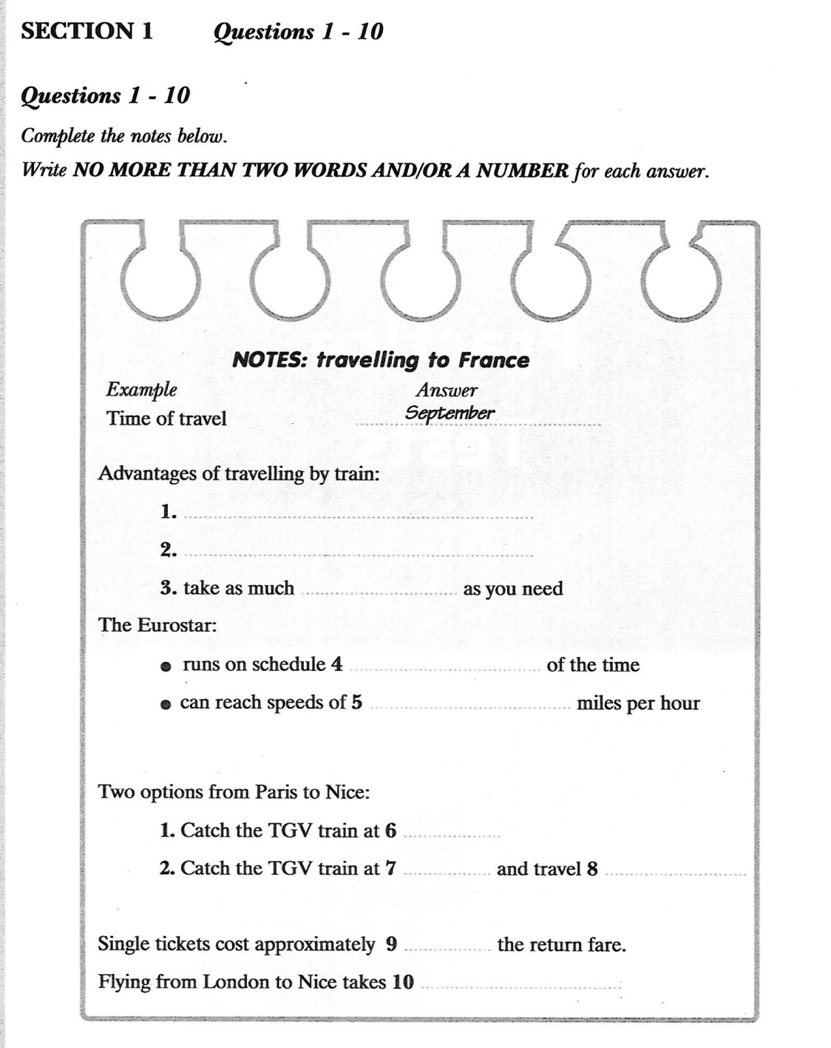

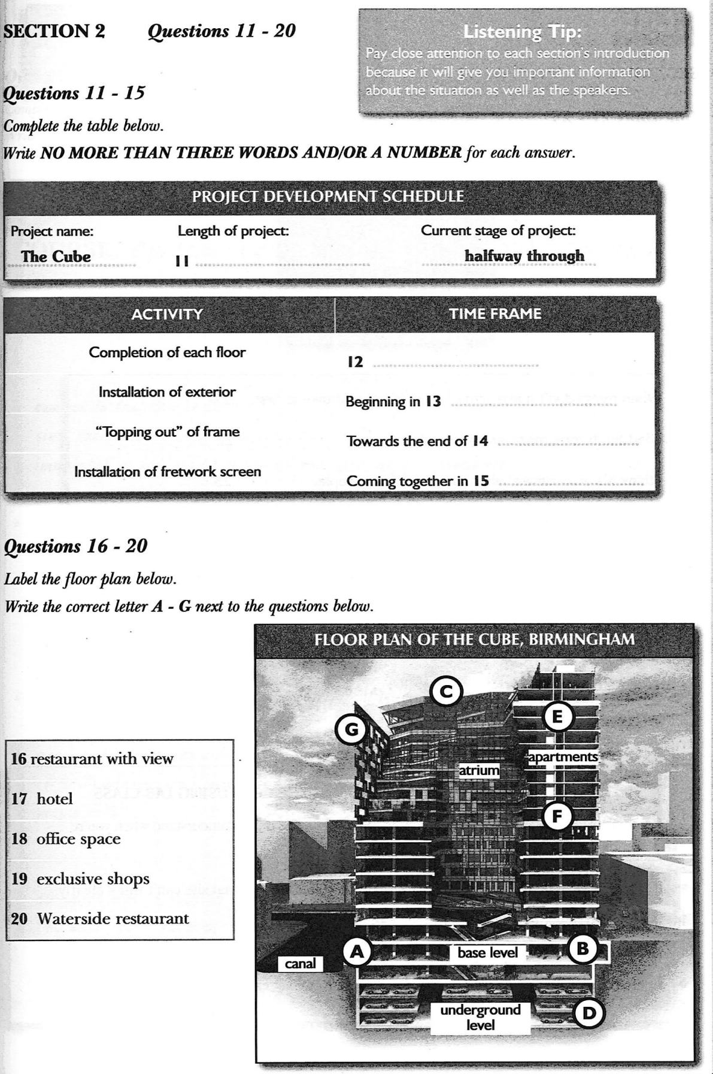 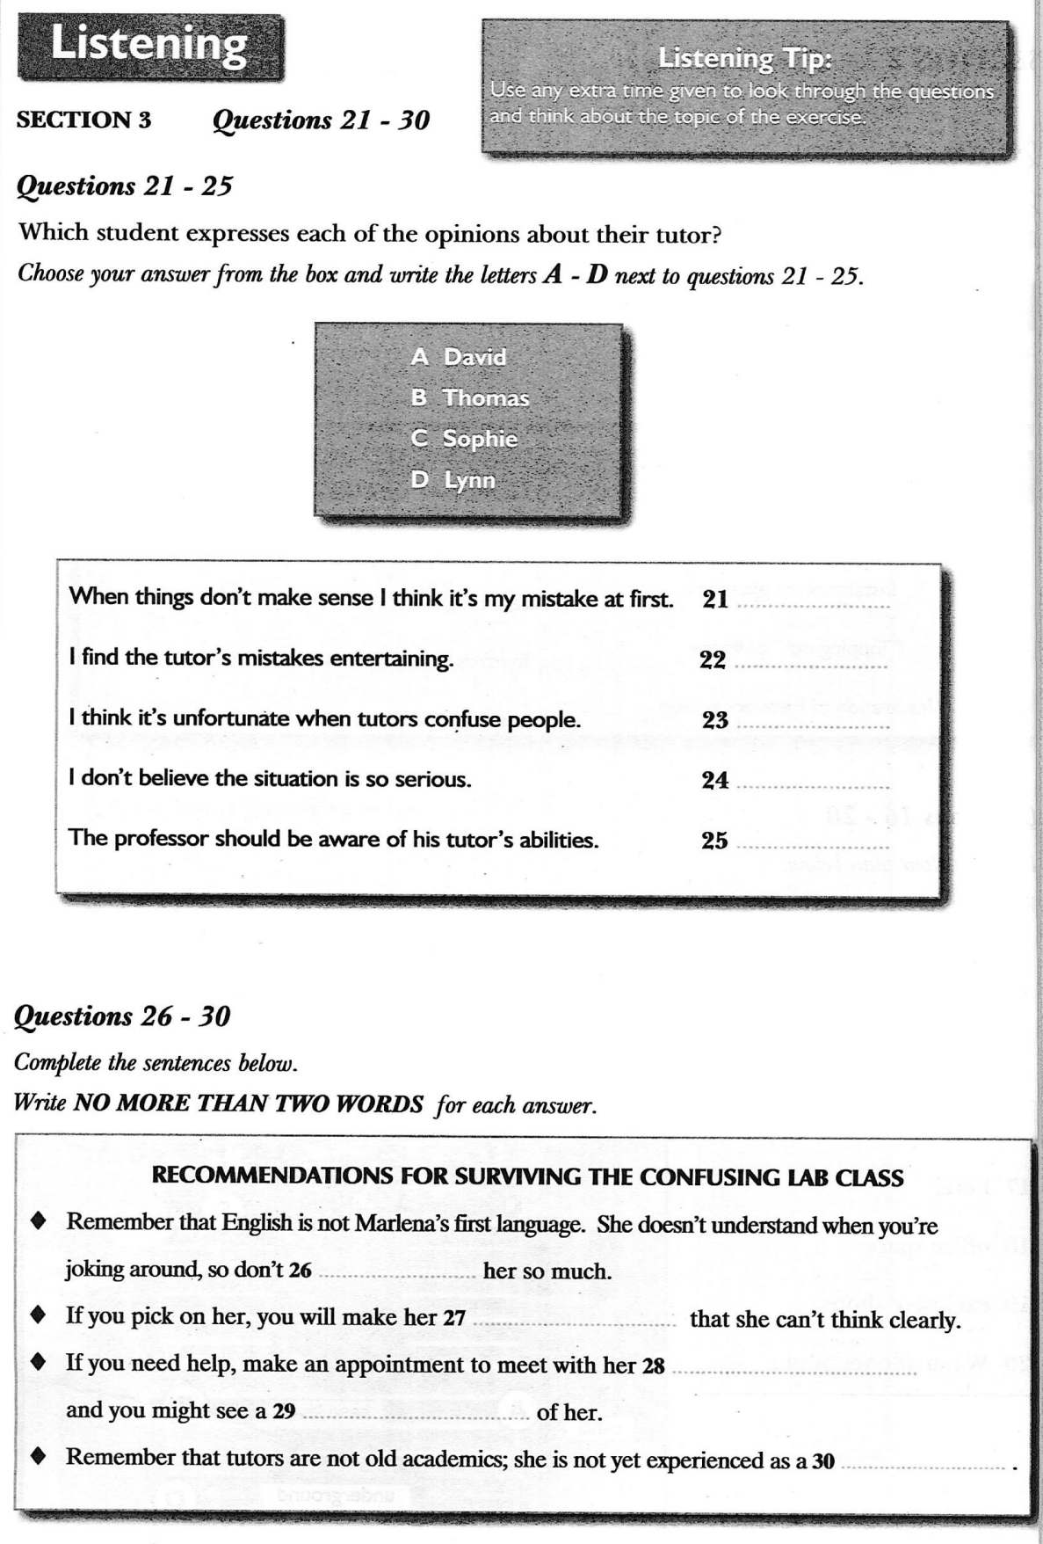 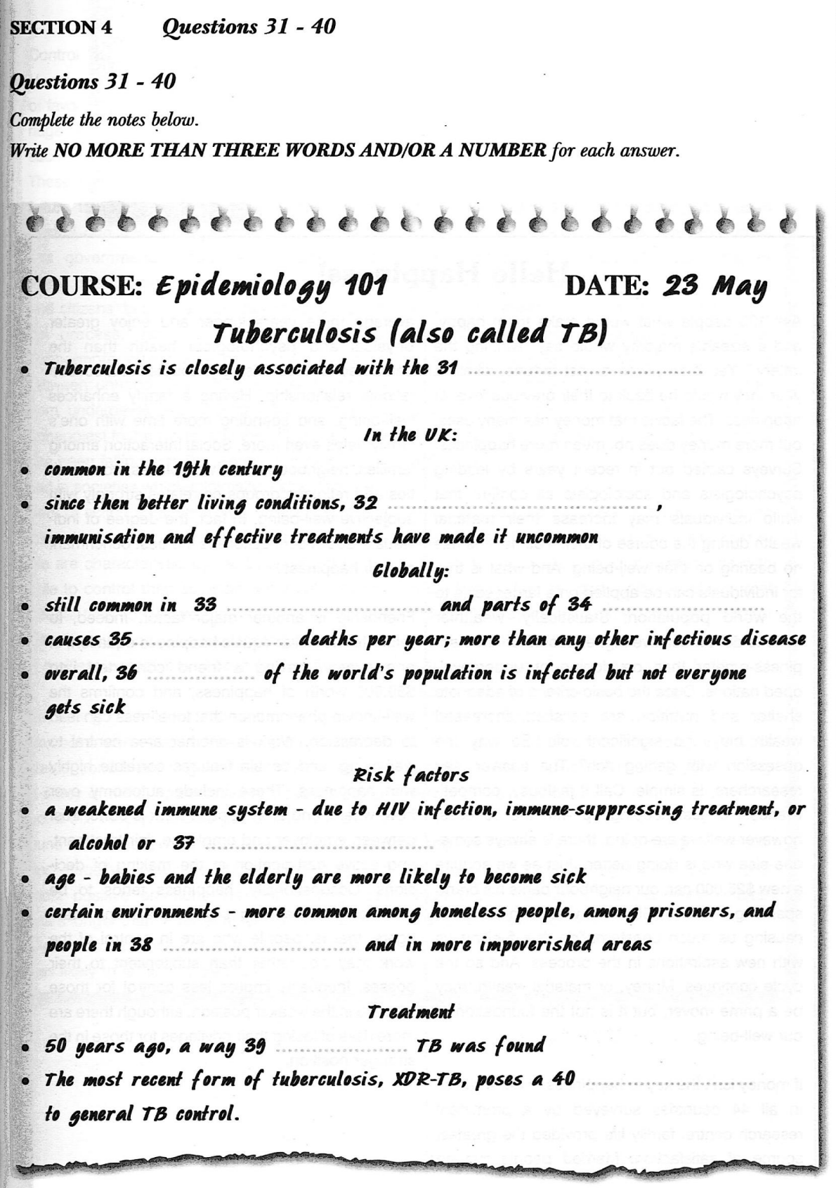

**TASK II: GAP-FILLING**

**Section 1**

F= Travel agent M= Student

F: Good morning!

M: Hi.

F: How can I help you?

M: I'm looking for information about travelling to **[...........France.......................]**. I’m studying in Nice next year and need to go there in September. I'm thinking of driving, so I guess it's either through the **[.........channel.........................]**, or by ferry. Um— I think the ferry's a lot slower, isn't it?

F: Indeed it is; it takes around nine hours from **[........London..........................]**to Paris, including the **[..............overland....................]**bits, and usually it's more expensive too, unless you book well ahead of time; then sometimes the ferry's more **[...............(Affordable)...................]**.

M: How much does it cost?**[..................................]**F: Well, when you take the train and the **[............ferry......................]**now, you must buy your tickets **[..........separately........................]…**

M: Actually I’d prefer to take the **[............(chunnel)......................]**. How much does that cost?

F: That depends on your travel date and availability of tickets, but you can **[..............expect....................]**to pay about **[..........(50) pounds........................]**each way for the car, in addition to your **[.........(passenger).......................]**fares.

M: It's not cheap.

F: No; will you be using your car a lot while you're in France?

M: Uh, not really, but I'll have a lot of **[...........luggage.......................]**, so it seems like the easiest way. Besides, I hate flying.

F: Driving is never the easiest way to get from the UK to France, I'm afraid! And of course, your **[............steering......................]**wheel will be on the wrong side when you get there! If you’re not going to need your car when you **[...........arrive.......................]**, may I suggest leaving it at home and travelling by train?

It's much faster, more affordable and you can take as much luggage as you need, there aren't limits.

M: Oh, I didn't know that about the luggage - that's good It would **[..................certainly................]**be more relaxing, I suppose. Ok, tell me about the train.

F: It's **[.............definitely.....................]**the most popular option these days. Eurostar has now captured over **[.........70%.........................]** of the London to Paris market from the **[..........airlines........................]**, and maybe this has something to do with the fact that **[.........92.4%.........................]**of Eurostar trains run on time, against just **[...........65%.......................]**of flights on the same **[.................routes.................]**. From central London to central Paris, Eurostar is faster than flying as well.

M: And the Eurostar is _ what exactly? A train company?

F: Oh, sorry! The Eurostar is the **[........highspeed..........................]**passenger train that runs from London to Paris via the Channel Tunnel. Eurostar can reach **[................186 miles..................]**per hour, and the journey takes just 2 hous 15 minutes.

M: All right, so it's easy to get to Paris, but what about Nice? It's a fair bit farther.

F: Yes, but it couldn't be easier. There are two main options; you can leave London at seven twenty-seven in the morning, then **[..........transfer........................]**in Paris to catch the TGV train at **[............11:46.....................]**, which takes about five and a half hours, and be in Nice in time for an evening meal. Or, you can take any Eurostar to Paris in time to catch the twentv-two twenty-five from Paris, which arrives in Nice at **[........8:54..........................]**. It's a longer journey, but many people prefer the **[..........convenience........................]**of travelling overnight.

M: Yes, that appeals to me. About how much does the overnight journey cost?

F: The example I've pulled up on the computer now costs a hundred and thirty-five pounds return, but sometimes it's lower as low as **[.............97 pounds.....................]**. I'll write down a couple of website **[...........addresses.......................]**for you, and you can search for various times and fares on your own.

M: Thanks, that’s great _ oh _ one more thing. Ill need a single fare, because I won't be returning for a while. Is that going to be more **[...............expensive...................]**?

F: No, don't worry. Singles are **[............approximately......................]**half of the return fare, though this wasn't true several years ago, when it wasn't **[........uncommon..........................]**for a return to be cheaper than a single.

Nt Ok, this sounds good, but what about flying? Is that an option?

F: If you aren't going to opt for taking the train, flying is another good option. While the train's the **[...........fastest.......................]**way to travel from London to Paris, you can actually save time by opting to fly from London to the South of France.

M: I guess there's an airport in Nice, isn't there?

F: Yes; the Nice Cote d'Azur Airport. It's about **[...............7 kilometers...................]** from the centre of Nice. Since it's the third most important airport in France after Charles de Gaulle and Orly in Paris, there's no **[............(shortage)......................]**of flights.

M: Do you know **[.........exactly.........................]**how long it takes?

F: Two hours.

M: That's quick!

F: Yes, but you need to consider that you'll lose time checking in and waiting to collect luggage and such. And of course, there's a **[...........baggage.......................]**allowance.

M: True. All right, thanks very much for your help. I've got a lot to think about now.

F: No problem at all. Feel free to come back if you have more questions.

**Section 2**

Good morning ladies and gentlemen! Thanks for joining me on our monthly **[............excursion......................]**to visit new **[...........architectural.......................]**and city planning devel opments in our city of Birmingham. Today, as you can see, we're here at the **[..............development....................]**site of “the Cube", and its construction is well **[...........(underway).......................]**. Indeed, the year ahead will be an exciting year for Birmingham Development Company and its **[........construction..........................]**arm, Buildability, as the construction of "the Cube', the most **[......spectacular............................]**building in Birmingham, continues at speed. This new building, valued at over **[..............a hundred million pounds....................]**, has been designed by the internationally renowned **[........architect(s)..........................]**, MAKE Their design team, led by Ken Shuttleworth, has created a **[............17 stor(e)y......................]**cube aimed at providing a spectacular contrast to the increasing number of towers appearing on the Birmingham **[.............cityscape.....................]**.

The complex **[.....................142 week.............]**building programme that will trans¬form the Birmingham **[......(skyline)............................]**upon its completion, is currently over halfway through its development. The building will continue to **[............rise......................]**, over the coming year, with each floor taking **[........2to 3 weeks..........................]**to complete. As you can see, to your right, the first **[................(shipment)..................]**of the special gold **[..........(anodized)........................]**cladding that will adorn the cube has now arrived onsite, and from February, the **[.................glistening.................]**golden **[...........(exterior).......................]**will begin to be installed, bringing the **[...........unique.......................]**building to life. Late summer will see the topping out1 of the **[..........concrete........................]**frame of the cube structure, with the **[...........(intricate).......................]**metallic fretwork screen beginning to take shape in the early **[...........Autumn.......................]**.

What has been **[......accomplished............................]**to date in the city's regeneration has been nothing short of amazing, yet we hope to set a new **[.......benchmark...........................]**for developments in Birmingham. The Cube will bring forward a new standard of architecture and a building, which will not only be Birmingham's most striking **[............waterside......................]**location, but also one wNch is **[..........identifiable........................]**around the world. The Cube breaks all the **[............bouderies......................]**of what has been achieved in Birmingham so far.

The finished Cube will be a mixed-use building. It will house the city’s first **[.............rooftop.....................]**restaurant with **[.......pandoramic...........................]**views whilst a boutique hotel and residential apartments below will feature **[........internal..........................]** views over the twisting atrium. Further down, high specification.

Grade A office space is planned with more exclusive retail and **[........waterside..........................]**restaurants at the base. The Mailbox has already raised the bar in the quality and **[..................................]**of our architecture and the **[...........retail.......................]**offerings, worldwide brand names and **[..............stylish....................]**restaurants have given Birmingham a **[..................contemporary................]**profile rivalling the capitals of Europe.

From the outset, the Cube's design team sought to create a new **[...............landmark...................]**building for Birmingham which fits into its context and which tows people in. Lined with coloured glass and with an **[..................................]**dad in **[.............exterior.....................]**metal fretwork, the Cube has visible links to Birmingham’s heritage in engineering and **[..................................]**manufacture It was essential that the building created a strong visual **[.............presence.....................]**, immediately identi¬fiable as a gateway to the **[..................................]**and city centre area to the north.

Our city is a city of the future and as a **[..........futuristic........................]**building with **[............phenominal......................]**foresight in style and design, the Cube is **[..................................]**of our plans in how we see Birmingham developing. The Cube will help to **[..........elevate........................]**us onto a global stage Now, let's go and have a look at the progress of the **[.........entrance.........................]**gateway.

**SECTION 3**

L= Lynn T= Thomas S= Sophie D= David

L Thomas, let's not go to the **[......lab............................]**. Let's just stay here in the student **[.............allowance.....................]**and drink tea and review the chapter.

T: You know we can't do that. We've a **[.......responsibility...........................]**to turn up and make sure our tutor has understood the week's lectures. If we don't go, no one will ever even **[........realise..........................]**she's got the **[..................theory................]**ail mudded upi S: Oh really?

L Sophie, it's awful Marlena just opens her mouth and I'm **[.....confuse.............................]**. Really, she…

T: Marlena's our tutor.

S: Yeah, I gathered that...

L You lot have got no **[........malaise..........................]**; I was in the middle of saying some¬thing? Shell say things that make no sense **[.......w...........................]**, and I'm thinking I've **[............misunderstood......................]**something, and f'm looking around the room and everyone has these looks on their faces of…

T: Disbelief and **[..................................]**!

L Maybe you do, Thomas, but we're not all **[.........genius.........................]**. Really, I'll be so worried that I've got it all wrong, then people start asking questions, and by and by we figure out that she's **[..............mixed....................]**something up.

S: That's too bad It's not a good situation at all.

D: But surely you're **[..........exaggerating........................]**a bit. Lynn…

L No, it’s awfuf I don’t know how she got through her undergraduate studies, much less got **[..................................]**as a **[..................................]**here. You'd think our professor would have some idea about her abilities.

D: Marlena's an unusual name. Is she English?

L She's Spanish, David She's got a really strong **[.....accent.............................]**- T: Really that's a lot of the problem, I think. I don't think she's thick; she just doesn't **[.......commuicate...........................]**very well. I'm not sure she understands us completely, especially when someone's **[........joking..........................]**around. And we do **[..................................]**her a bit I must admit

S: What a nightmare! I'd hate to have you in my class if I was a tutor, Tom!

T: As long as you're **[..........clever........................]**Sophie, you'd have nothing to worry about...

S: But you've just said she's not thick!

D: I think I've met her, actually; I think we had a class **[.....together.............................]**, maybe last year. She was really shy and quiet Hardly spoke the whole term. But she was always **[........smiley..........................]**and friendly. She seemed nice, actually, and I think she got one of the **[.....higher.............................]**marks in the class. Maybe you've all picked on her so much that she's so **[..........nervous........................]**that she cant think clearly. Ever think of that?

L But we don't need to baby-sit; we need help! It’s a difficult subject!

S: Has anyone ever gone up and asked her for help **[......individually............................]**?

T: Yes, actually, I have. I couldn't understand one of the **[..........formula........................]**in the first chapter - the theory about why it worked just made no **[.........sense.........................]**to me, so I went and asked her about it and she cleared it right up. She was very **[.........helpful.........................]**. She's not thick; I already said that.

S: She's just so much fun to **[........t..........................]**, right?

T: Yep, that’s it!

S: Lynn, if you are having **[..............trouble....................]**with something why don't you make an **[.........appointment.........................]**to meet with her individually and see if she can help you that way? Maybe you'd see a different side of her. I reckon she just hates getting up in front of the class and I can hardly **[..................................]**her.

L Yes, I could try that I suppose.

D: Guys, the tutors aren't old **[......academic............................]**who've been teaching for thirty years; they're just like us, two years down the road, if we're clever enough to continue with our **[...........education.......................]**. I know I'd be **[..................................]**to get up in front of you lot, and I dont think I'll feel that differently in a couple of years' time. You know, we're far more **[...........experienced.......................]**as students than they are as teachers.

T: You're right, David. Really, it’s more like one of our **[.........mate.........................]**is trying to help us out, but you know, our mates aren't so **[.................frightened.................]**of us!

S: Yeah, but you aren't so **[.........horrible.........................]**to your mates, are you?

**SECTION 4**

Hello there; can I have your **[.......attention...........................]**please? We've got a lot to cover today and we need to get started If you recall, last week we **[..........discussed........................]**the AIDS **[...............epidemic...................]**, and its effect on health care systems in the countries with the highest **[.....incident.............................]**. Well, today I'm going to speak about another **[..............significant....................]**disease that is rather closely associated with the AIDS epidemic - **[..........tuberculosis........................]**.

In the UK, active Tuberculosis, otherwise known as TB, was com¬mon in the **[..............19th....................]**century - the old ‘consumption’ of romantic novels. Since then, better living conditions, better nutrition, **[..................................]**and effective treatments in the twentieth century have all **[.............combine.....................]**to make TB uncommon in the UK today. However. TB is still common in developing countries and parts of Eastern Europe. It causes more deaths **[............worldwide......................]**than any other **[..............infection....................]**disease - about three million per year. This is a tragic **[..................................]**since TB is now generally a **[..........curable........................]**disease. Overall, one third of the workfs population is currentfy infected with the bacteria that cause TB. However, people infected with TB **[..................................]**will not necessari¬ly become sick with the disease. The immune system "walls off" the TB bacilli which, protected by a thick **[..................................]**coat can lie **[..................................]**for years. It's estimated that **[..............5 to 10%....................]**of people who are **[.......infected...........................]**with TB bacilli, but who are not infected with HIV, become sick or infectious at some time during their life. Left **[..........untreated........................]**, each person with active TB disease will infect on average between 10 and 15 peo¬ple every year.

There are certain risk factors that make certain people more like¬ly to become ill with TB. When people's **[..........immune........................]**systems are weak¬ened, their chances of becoming sick are greater, for example, due to HIV infection, **[..................................]**treatment, or alcohol or drug addiction. Age is also a factor, with babies, young children and the elderly being most **[.........susceptible.........................]**. In addition, poor nutrition and lack of vitamin D are linked to TB. Finally, TB is more common in cer¬tain environments such as among **[................homeless..................]**people, among prisoners, in large cities and in more **[...........impoverished.......................]**areas.

Until **[..............50 years....................]**ago, there were no medicines to cure TB. Finding medicines to cure TB was a **[..........tremendous........................]**breakthrough.

But now, strains that are **[............resistant......................]**to a single drug have been docu-mented in every country **[............survey......................]**what's more, strains of TB resist¬ant to all major anti-TB drugs have emerged. Drug-resistant TB is caused by **[............inconsistent......................]**or partial treatment, when patients do not take all their medcines regularly for the required period because they start to feel better, because doctors and health workers **[.............describe.....................]**the wrong treatment **[..................................]**, or because the drug supply is unreli¬able.

A particularly dangerous form of **[...........drug-resistant.......................]**TB is multidrug- resistant TB, **[..........abbreviated........................]**as MDR TB, which is defined as the disease caused by TB bacilli resistant to at least the two most powerful anti- TB drugs. Rates of MDR-TB are high in some countries, especially in the former Soviet Union, and **[..................................]**TB control efforts. While drug- resistant TB is generally **[........treatful..........................]**, it requires extensive chemothera¬py - up to two years of treatment - with second-line anti-TB drugs These second-line drugs are more costly than first-line drugs, and produce **[..................................]**drug reactions that are more severe, though still **[.........manageable.........................]**.

The recent emergence of **[...........extensively.......................]**drug-resistant TB. called XDR-TB, particularly in settings where many TB patients are also **[.........infected.........................]**with HV, poses a serious threat to TB control and con¬firms the urgent need to **[.............strengthen.....................]**basic TB control and to apply the new WHO guidelines for the **[.........management.........................]**of drug-resistant TB.